

SIMATS ENGINEERING

Saveetha Institute of Medical and Technical Sciences
Chennai- 602105

Student Name: P. Durga Prasanth Reg. No.: 192424246
Course Code: DSA0613 Slot: A
Course Name: Data Handling and Visualization for Data Analytics
Course Faculty: Dr Kumaragurubaran T, Dr Senthilvadivu S
Project Title: Healthcare: Interactive Medical Data Transformation & Dynamic Visualization System
Module Photographs:
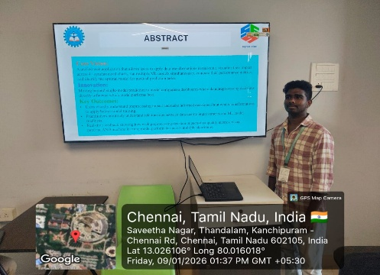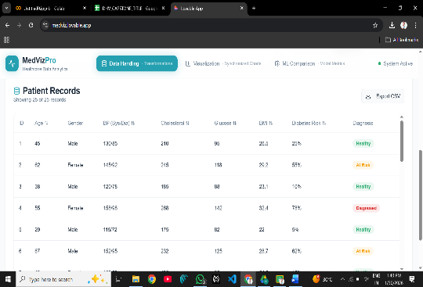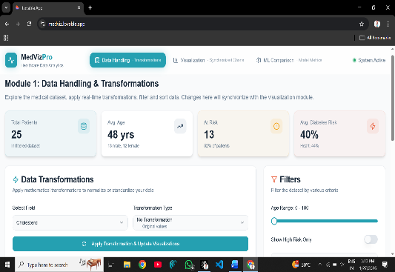
Project Description:
Advanced statistical analysis engine computing comprehensive descriptive statistics (mean, median, quartiles, skewness, kurtosis), distribution analysis (Shapiro-Wilk normality testing, Q-Q plots), correlation analysis (Pearson, Spearman, Kendall Tau with significance testing), and comparative statistics (independent t-tests, Mann-Whitney U, ANOVA, chi-square) across all numerical and categorical healthcare features. Automatically identifies clinically significant patterns including strong correlations (>0.7), non-normal distributions requiring transformation, and statistically significant group differences (p<0.05). Generates executive summary reports with quality benchmarks, effect sizes, confidence intervals, and prioritized clinical insights ready for evidence-based medical decision making.
Statistical analysis engine computing descriptive statistics, correlation matrices, normality tests, and comparative analyses (t-tests, ANOVA) across healthcare features, generating comprehensive quality reports and clinical insights from processed datasets.

Student Signature Guide Signature

